CREATE TABLE IF NOT EXISTS Employee(

ENO BIGINT,

FNAME VARCHAR(50) NOT NULL,

LNAME VARCHAR(50) NOT NULL,

DESIG VARCHAR(50),

MGR BIGINT,

DOB DATE,

HDATE DATE,

Salary NUMERIC(8, 2),

Commission NUMERIC(8, 2),

CONSTRAINT pkey PRIMARY KEY (ENO),

CONSTRAINT foreign_key FOREIGN KEY (MGR) REFERENCES Employee (ENO),

CONSTRAINT DOB_Check CHECK ( YEAR(DOB) &lt;= 1980 ),

CONSTRAINT Salary_Check CHECK ( Salary BETWEEN 20000 AND 100000 )

);

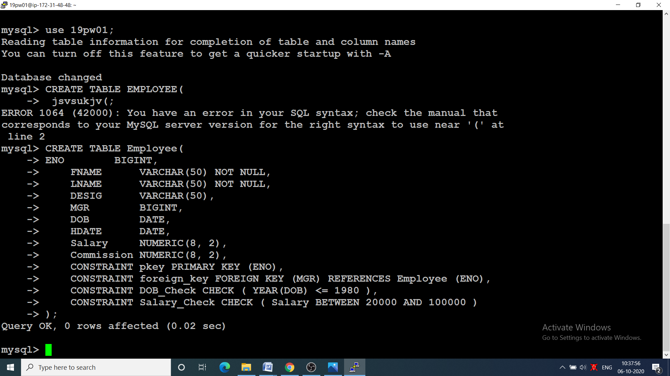

INSERT INTO Employee

VALUES (101, &#39;Janson&#39;, &#39;Hass&#39;, &#39;President&#39;, NULL, STR_TO_DATE(&#39;12/09/1973&#39;, &#39;%d/%m/%Y&#39;),

STR_TO_DATE(&#39;12/01/2003&#39;, &#39;%d/%m/%Y&#39;), 87500.00, NULL),

(110, &#39;James&#39;, &#39;Thompson&#39;, &#39;Manager&#39;, 101, STR_TO_DATE(&#39;06/01/1973&#39;, &#39;%d/%m/%Y&#39;),

STR_TO_DATE(&#39;25/02/2008&#39;, &#39;%d/%m/%Y&#39;), 52950.00, NULL),

(115, &#39;Celia&#39;, &#39;Geyer&#39;, &#39;Manager&#39;, 101, STR_TO_DATE(&#39;07/09/1972&#39;, &#39;%d/%m/%Y&#39;),

STR_TO_DATE(&#39;17/09/2007&#39;, &#39;%d/%m/%Y&#39;), 46850.00, 22530.00),

(117, &#39;Robert&#39;, &#39;Stern&#39;, &#39;Manager&#39;, 101, STR_TO_DATE(&#39;04/02/1972&#39;, &#39;%d/%m/%Y&#39;),

STR_TO_DATE(&#39;15/03/2006&#39;, &#39;%d/%m/%Y&#39;), 49900.00, 20555.00),

(135, &#39;Linda&#39;, &#39;Pulaski&#39;, &#39;Salesman&#39;, 110, STR_TO_DATE(&#39;29/08/1968&#39;, &#39;%d/%m/%Y&#39;),

STR_TO_DATE(&#39;19/09/2007&#39;, &#39;%d/%m/%Y&#39;), 21250.00, 14500.00),

(142, &#39;David&#39;, &#39;Henderson&#39;, &#39;Salesman&#39;, 110, STR_TO_DATE(&#39;02/02/1970&#39;, &#39;%d/%m/%Y&#39;),

STR_TO_DATE(&#39;23/03/2006&#39;, &#39;%d/%m/%Y&#39;), 21700.00, 12400.00),

(167, &#39;Martin&#39;, &#39;Spenser&#39;, &#39;Salesman&#39;, 110, STR_TO_DATE(&#39;09/02/1971&#39;, &#39;%d/%m/%Y&#39;),

STR_TO_DATE(&#39;28/07/2005&#39;, &#39;%d/%m/%Y&#39;), 27000.00, 16600.00),

(172, &#39;Smith&#39;, &#39;Nicholls&#39;, &#39;Clerk&#39;, 110, STR_TO_DATE(&#39;12/03/1965&#39;, &#39;%d/%m/%Y&#39;),

STR_TO_DATE(&#39;26/04/2003&#39;, &#39;%d/%m/%Y&#39;), 21850.00, NULL),

(154, &#39;Larry&#39;, &#39;Adamson&#39;, &#39;Salesman&#39;, 110, STR_TO_DATE(&#39;02/02/1974&#39;, &#39;%d/%m/%Y&#39;),

STR_TO_DATE(&#39;18/02/2004&#39;, &#39;%d/%m/%Y&#39;), 22250.00, 17000.00),

(179, &#39;Mathews&#39;, &#39;Pinka&#39;, &#39;Analyst Manager&#39;, 117, STR_TO_DATE(&#39;08/01/1975&#39;, &#39;%d/%m/%Y&#39;),

STR_TO_DATE(&#39;23/04/2008&#39;, &#39;%d/%m/%Y&#39;), 35000.00, NULL),

(183, &#39;Sally&#39;, &#39;Brown&#39;, &#39;Clerk&#39;, 179, STR_TO_DATE(&#39;29/08/1968&#39;, &#39;%d/%m/%Y&#39;),

STR_TO_DATE(&#39;14/07/2008&#39;, &#39;%d/%m/%Y&#39;), 21250.00, NULL),

(190, &#39;Christine&#39;, &#39;Jones&#39;, &#39;Analyst Manager&#39;, 117, STR_TO_DATE(&#39;13/09/1968&#39;, &#39;%d/%m/%Y&#39;),

STR_TO_DATE(&#39;05/09/2005&#39;, &#39;%d/%m/%Y&#39;), 34000.00, NULL),

(199, &#39;Michael&#39;, &#39;Parker&#39;, &#39;Clerk&#39;, 190, STR_TO_DATE(&#39;07/02/1971&#39;, &#39;%d/%m/%Y&#39;),

STR_TO_DATE(&#39;17/03/2004&#39;, &#39;%d/%m/%Y&#39;), 21600.00, NULL),

(200, &#39;John&#39;, &#39;Mehta&#39;, &#39;Clerk&#39;, 115, STR_TO_DATE(&#39;02/03/1975&#39;, &#39;%d/%m/%Y&#39;),

STR_TO_DATE(&#39;12/02/2006&#39;, &#39;%d/%m/%Y&#39;), 21350.00, NULL),

(137, &#39;Bruce&#39;, &#39;Wong&#39;, &#39;Salesman&#39;, 110, STR_TO_DATE(&#39;12/12/1976&#39;, &#39;%d/%m/%Y&#39;),

STR_TO_DATE(&#39;18/10/2005&#39;, &#39;%d/%m/%Y&#39;), 22250.00, 13000.00);

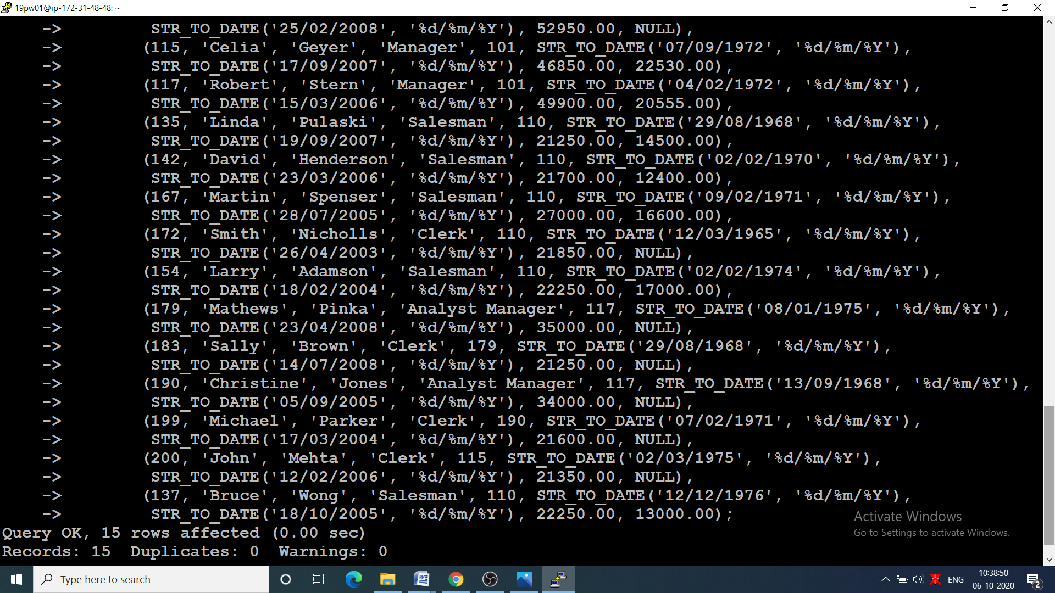

|  |  |  |
| --- | --- | --- |
|  | 1.) | |
|  | SELECT * | |
|  | FROM Employee | |
|  | WHERE DOB <= ANY (SELECT DOB FROM Employee WHERE ENO = 167);  Screenshot (114).png | |
|  |  | |
|  | 2.) | |
|  | SELECT FNAME, LNAME | |
|  | FROM Employee | |
|  | WHERE TIMESTAMPDIFF(YEAR, DOB, CURRENT_TIMESTAMP) < 30;  Screenshot (115).png | |
|  |  | |
|  | 3.) | |
|  | SELECT * | |
|  | FROM Employee | |
|  | WHERE LNAME LIKE '%er%';  Screenshot (115).png | |
|  |  | |
|  | 4.) | |
|  | SELECT FNAME, LNAME | |
|  | FROM Employee | |
|  | WHERE FNAME REGEXP '^[MJ]\w*';  Screenshot (116).png | |
|  |  | |
|  | 5.) | |
|  | SELECT FNAME, LNAME, Salary | |
|  | FROM Employee | |
|  | WHERE DESIG LIKE '%Manager%';  Screenshot (117).png | |
|  |  | |
|  | 6.) | |
|  | SELECT * | |
|  | FROM Employee | |
|  | WHERE DOB IN (SELECT MIN(DOB) FROM Employee);  Screenshot (118).png | |
|  |  | |
|  | 7.) | |
|  | SELECT * | |
|  | FROM Employee | |
|  | WHERE DESIG NOT IN ('Manager', 'Analyst Manager');  Screenshot (119).png | |
|  |  | |
|  | 8.) | |
|  | SELECT * | |
|  | FROM Employee | |
|  | WHERE Salary > 35000 | |
|  | AND (YEAR(DOB) BETWEEN 1966 AND 1976);  Screenshot (120).png | |
|  |  | |
|  | 9.) | |
|  | SELECT FNAME, LNAME, DESIG, Salary | |
|  | FROM Employee | |
|  | WHERE Salary >= 35000 | |
|  | AND DESIG IN ('Manager', 'Analyst Manager');  Screenshot (121).png | |
|  |  | |
|  | 11.) | |
|  | SELECT ENO, FNAME, LNAME, DESIG, Salary | |
|  | FROM Employee | |
|  | WHERE Commission >= 15000 | |
|  | AND DESIG IN ('Manager', 'Salesman');  Screenshot (122).png | |
|  |  | |
|  | 11.) | |
|  | SELECT DESIG, COUNT(DESIG) | |
|  | FROM Employee | |
|  | GROUP BY DESIG; | |
|  | Screenshot (123).png | |
|  | 12.) | |
|  | SELECT ENO, LNAME, Salary | |
|  | FROM Employee | |
|  | WHERE LNAME IN ('Thompson', 'Spenser', 'Geyer', 'Brown', 'Jones');  Screenshot (124).png | |
|  |  | |
|  | 13.) | |
|  | SELECT YEAR(HDATE), COUNT(*) | |
|  | FROM Employee | |
|  | GROUP BY YEAR(HDATE) | |
|  | ORDER BY YEAR(HDATE);  Screenshot (125).png | |
|  |  | |
|  | 14.) | |
|  | SELECT ENO, LNAME, Salary, TIMESTAMPDIFF(YEAR, DOB, CURRENT_TIMESTAMP) | |
|  | FROM Employee | |
|  | WHERE TIMESTAMPDIFF(YEAR, DOB, CURRENT_TIMESTAMP) BETWEEN 30 AND 40;  Screenshot (126).png |
|  |  |
|  | 15.) | |
|  | SELECT FNAME | |
|  | FROM Employee | |
|  | WHERE MGR IN (SELECT ENO FROM Employee WHERE FNAME IN ('James', 'Robert', 'Celia'));  Screenshot (127).png | |
|  |  | |
|  | 16.) | |
|  | SELECT CONCAT('"', FNAME, '","', LNAME, '","', DESIG, '"') | |
|  | FROM Employee;  Screenshot (128).png | |
|  |  | |
|  | 17.) | |
|  | SELECT * | |
|  | FROM Employee | |
|  | WHERE Commission IS NOT NULL | |
|  | ORDER BY DOB DESC | |
|  | LIMIT 1;  Screenshot (129).png | |
|  |  | |
|  | 18.) | |
|  | SELECT CONCAT('Dear \'',FNAME,'\', you were born on ',DATE_FORMAT(DOB, '%d, %D - %M - %Y')) | |
|  | FROM Employee;  Screenshot (130).png | |
|  |  | |
|  | 19.) | |
|  | SELECT * | |
|  | FROM Employee | |
|  | WHERE (DESIG, Salary) IN (SELECT DESIG, MAX(Salary) FROM Employee GROUP BY DESIG);  Screenshot (131).png | |
|  |  | |
|  | 20.) | |
|  | SELECT * | |
|  | FROM Employee  WHERE MONTH(DOB) IN (1, 2, 8); | |
|  | Screenshot (132).png | |
|  |  | |
|  | 21.) | |
|  | SELECT CONCAT(FNAME, ' ', LNAME) AS Name, | |
|  | Salary, | |
|  | Commission, | |
|  | Salary + COALESCE(Commission, 0) AS 'Total Remuneration' | |
|  | FROM Employee;  Screenshot (133).png | |
|  |  | |
|  | 22.) | |
|  | SELECT CONCAT(FNAME, ' ', LNAME) AS Name, | |
|  | Salary, | |
|  | COALESCE(Commission, NOT ISNULL(Commission)), | |
|  | Salary + COALESCE(Commission, 0) AS 'Total Remuneration' | |
|  | FROM Employee;  Screenshot (134).png | |
|  |  | |
|  | 23.) | |
|  | SELECT FNAME | |
|  | FROM Employee | |
|  | WHERE (DESIG, HDATE) IN (SELECT DESIG, MIN(HDATE) FROM Employee GROUP BY DESIG);  Screenshot (135).png | |
|  |  | |
|  | 24.) | |
|  | SELECT * | |
|  | FROM Employee | |
|  | WHERE DESIG = 'Manager' | |
|  | AND YEAR(DOB) < 1973 | |
|  | AND Salary > 40000;  Screenshot (136).png | |
|  |  | |
|  | 25.) | |
|  | SELECT * | |
|  | FROM Employee | |
|  | WHERE Commission IS NULL | |
|  | AND Salary BETWEEN 25000 AND 35000;  Screenshot (137).png | |
|  |  | |
|  | 26.) | |
|  | SELECT * | |
|  | FROM Employee | |
|  | WHERE MONTH(DOB) = MONTH(HDATE);  Screenshot (138).png | |
|  |  | |
|  | 27.) | |
|  | SELECT ENO, FNAME, DATE_FORMAT(HDATE, '%M %d,%Y') | |
|  | FROM Employee;  Screenshot (139).png | |
|  |  | |
|  | 28.) | |
|  | SELECT ENO, | |
|  | CONCAT(FNAME, ' ', LNAME) AS Name, | |
|  | DESIG, | |
|  | HDATE, | |
|  | TIMESTAMPDIFF(YEAR, HDATE, CURRENT_TIMESTAMP) AS Experience | |
|  | FROM Employee | |
|  | WHERE ENO IN (SELECT DISTINCT MGR FROM Employee WHERE MGR IS NOT NULL);  Screenshot (140).png | |
|  |  | |
|  | 29.) | |
|  | SELECT ENO, | |
|  | CONCAT(FNAME, ' ', LNAME) AS Name, | |
|  | Salary | |
|  | FROM Employee | |
|  | WHERE TIMESTAMPDIFF(YEAR, HDATE, CURRENT_TIMESTAMP) > 5 | |
|  | AND DESIG IN ('Manager', 'Analyst Manager') | |
|  | AND Commission IS NULL | |
|  | ORDER BY ENO;  Screenshot (141).png | |
|  |  | |
|  | 30.) | |
|  | SELECT * | |
|  | FROM Employee | |
|  | WHERE HDATE > (SELECT HDATE FROM Employee WHERE FNAME = 'Martin');  Screenshot (142).png | |
|  |  | |
|  | 31.) | |
|  | SELECT FNAME | |
|  | FROM Employee | |
|  | WHERE Salary IN (SELECT Salary FROM Employee WHERE FNAME = 'Larry');  Screenshot (143).png | |
|  |  | |
|  | 32.) | |
|  | SELECT FNAME | |
|  | FROM Employee | |
|  | WHERE DESIG IN (SELECT DESIG FROM Employee WHERE FNAME = 'James') # Should james be included are not? | |
|  | AND Salary > (SELECT Salary FROM Employee WHERE FNAME = 'Celia');  Screenshot (144).png | |
|  |  | |
|  |  | |
|  | 33.)  SELECT * | |
|  | FROM Employee | |
|  | WHERE (Salary + COALESCE(Commission, 0)) = | |
|  | (SELECT MAX(Salary + COALESCE(Commission, 0)) FROM Employee);  Screenshot (145).png | |
|  |  | |
|  | 34.) | |
|  | SELECT * | |
|  | FROM Employee | |
|  | WHERE DESIG = 'Salesman' | |
|  | AND HDATE = (SELECT MAX(HDATE) FROM Employee WHERE DESIG = 'Salesman');  Screenshot (147).png | |
|  |  | |
|  | 35.) | |
|  | SELECT * | |
|  | FROM Employee | |
|  | WHERE MGR = 110 | |
|  | AND HDATE < (SELECT MAX(HDATE) FROM Employee WHERE MGR = 110);  Screenshot (148).png | |
|  |  | |
|  | 36 | |
|  | SELECT * | |
|  | FROM Employee | |
|  | WHERE HDATE < (SELECT MAX(HDATE) FROM Employee WHERE YEAR(HDATE) >= 1991);  Screenshot (165).png | |
|  |  | |
|  | 37.) | |
|  | SELECT CONCAT(FNAME, ' ', LNAME) AS Name | |
|  | FROM Employee | |
|  | WHERE Salary >= (SELECT (MIN(Salary) + MAX(Salary)) / 2 FROM Employee);  Screenshot (149).png | |
|  |  | |
|  | 38.) | |
|  | SELECT CONCAT(FNAME, ' ', LNAME) AS Name | |
|  | FROM Employee | |
|  | ORDER BY (Salary + COALESCE(Commission, 0)) | |
|  | LIMIT 5;  Screenshot (151).png | |
|  |  | |
|  | 39 | |
|  | SELECT CONCAT(FNAME, ' ', LNAME) AS Name, | |
|  | Salary, | |
|  | COALESCE(Commission, NOT ISNULL(Commission)) AS 'Commission', | |
|  | Salary + COALESCE(Commission, 0) AS 'Netpay' | |
|  | FROM Employee | |
|  | WHERE (Salary + COALESCE(Commission, 0)) = (SELECT MAX(Salary + COALESCE(Commission, 0)) FROM Employee);  Screenshot (152).png | |
|  |  | |
|  | 40.) | |
|  | SELECT CONCAT(FNAME, ' ', LNAME) AS Name | |
|  | FROM Employee | |
|  | WHERE HDATE IN (SELECT HDATE FROM Employee GROUP BY HDATE HAVING COUNT(*) > 1); | |
|  |  | |
|  | 41.) | |
|  | SELECT COUNT(*) | |
|  | FROM Employee | |
|  | WHERE MGR IS NULL; | |
|  |  | |
|  | 42 | |
|  | SELECT CONCAT(FNAME, ' ', LNAME) AS Name | |
|  | FROM Employee | |
|  | WHERE ENO IN (SELECT MGR | |
|  | FROM Employee | |
|  | GROUP BY MGR | |
|  | HAVING COUNT(*) = (SELECT COUNT(*) FROM Employee GROUP BY MGR ORDER BY COUNT(*) DESC LIMIT 1)); | |
|  |  | |
|  |  | |
|  | 43.) | |
|  | SELECT * | |
|  | FROM Employee | |
|  | WHERE (DESIG, HDATE) IN (SELECT DESIG, MAX(HDATE) FROM Employee GROUP BY DESIG) | |
|  | ORDER BY HDATE; | |
|  |  | |
|  | 44.) | |
|  | SELECT CONCAT(FNAME, ' ', LNAME) AS Name, DESIG | |
|  | FROM Employee | |
|  | WHERE Commission IS NOT NULL | |
|  | AND Salary IN (SELECT MAX(Salary) FROM Employee WHERE Commission IS NOT NULL); | |
|  |  | |
|  | 45.) | |
|  | SELECT * | |
|  | FROM Employee | |
|  | WHERE Salary IN (SELECT Salary FROM Employee GROUP BY Salary HAVING COUNT(*) > 1); | |
|  |  | |
|  | 46.) | |
|  | SELECT DESIG, AVG(Salary) | |
|  | FROM Employee | |
|  | WHERE DESIG != 'President' | |
|  | GROUP BY DESIG | |
|  | ORDER BY AVG(Salary) DESC | |
|  | LIMIT 1; | |
|  |  | |
|  | 47.) | |
|  | SELECT ENO | |
|  | FROM Employee | |
|  | WHERE ENO NOT IN (SELECT DISTINCT MGR FROM Employee WHERE MGR IS NOT NULL); | |
|  |  | |
|  | 48.) | |
|  | SELECT SUM(Salary + COALESCE(Commission, 0)) AS 'Total Remuneration' | |
|  | FROM Employee | |
|  | WHERE MGR = 110; | |
|  |  | |
|  | 49.) | |
|  | UPDATE Employee | |
|  | SET Commission = Commission + (Salary * 0.1) | |
|  | WHERE MONTH(DOB) = MONTH(CURRENT_DATE); | |
|  |  | |
|  | 50.) | |
|  | DELETE | |
|  | FROM Employee | |
|  | WHERE Salary > 40000 | |
|  | AND DESIG NOT IN ('President', 'Manager');  Screenshot (161).png | |